[Date]
Dear Parent/carer,
I’m delighted to inform you that ___________________________________ has been chosen to represent the school at the Times Tables Rock Wrangle being held at Bloomberg’s offices in central London on Friday June 26th. As you may already know, some of the students have been taking part in Times Tables Rock Stars in their maths lessons, to help improve their accuracy and speed at times tables. Our four fastest and most accurate rock stars have been selected to take part in this inaugural event.
The Times Tables Rock Wrangle is a competition for year 7s and 8s from London schools who have been taking part in Times Tables Rock Stars. After a series of heats, quarter-finals and semi-finals, 160 contestants will be whittled down to 4, who will compete in a grand finale in front of an audience of 200 people!
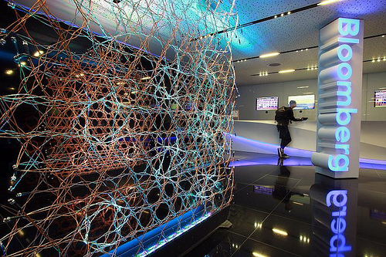
The winning student and their school team and their teacher will then be chauffeur driven to a heliport in Battersea and enjoy a 20 minute flight over London. They will also be accompanied by a videographer who will capture the experience with them.
As if it wasn’t great enough already – with the inspiring office building, the high-octane competition and the VIP prize – there are some other parts of the day to get excited about.
There will be a short presentation on life and careers at Bloomberg, as well as tours to see the famous fish tanks, all-you-can-eat food station and TV studio. There will also be a mini festival called MathsStock, which will involve maths riddles with Bloomberg volunteers, band photos and an air guitar competition!
This is an amazing opportunity for your son/daughter to use their maths skills and to be rewarded for the hard work they have put into improving their times tables over the year.
The event will be covered by local news organisations, so if you consent for your child to attend, you will also have to consent for them to appear in the media. I will let you know if the kids feature in any news articles, so that you can get a copy for yourself too!
Yours sincerely,
[Teacher Name]
Maths teacher

Please keep this part at home
**********************************************************************************
Details:
Date: Friday 26th June
Arrival: Arrive at school at usual time for a departure of 9:00am.
The students will travel by tube with me to the Bloomberg offices in Central London
Lunch: Lunch will be provided for free at the venue
Return: Students are expected to return to school at 3:00pm and attend PM registration as usual.
If the students win the helicopter ride, we will arrive at the later time of 4:45pm. You will be informed if this is the case.

**********************************************************************************

Please return the slip below by [date]
---------------------------------------------------------------------------------------------------------------------------------
London Times Tables Rock Wrangle 2015
I consent for my son/daughter: ________________________________________ to attend the Times Tables Rock Wrangle on Friday June 26th.
By allowing them to attend I also consent to them flying in a helicopter (if they win the competition) and appearing in the media.

Signed: ___________________________________ (parent/carer)
Date: _____________________________________

Does your child have any dietary requirements and/or allergies? Yes / No (please circle)
If yes, please list here: ____________________________________________________________________________________________________________________________________________________________________________________________________________________________________________________________

