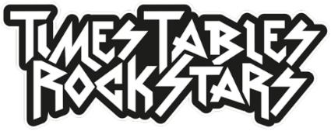

Dear parent/carer,
To mark the awesome date that is 12th March 2021 (12-3-21, which reads the same forward as backwards) and to make maths exciting and high profile in our school, we are holding a Battle of the Bands (an in-school times tables competition) in aid of Red Nose Day. It is part of a UK-wide Rock Down Relief event run by Times Tables Rock Stars and will be the biggest times tables event in the country ever!
Starting on Friday 12th March and ending on Thursday 18th March 2021, the whole competition is done online via play.ttrockstars.com or the TT Rock Stars app. For every correct answer to a multiplication or division question, your child will earn their class a point. The Times Tables Rock Stars platform will calculate the class average (the number of correct answers per pupil in the class who play during the competition hours). Winning classes in the school will be the ones with the highest average.
All game modes (Gig, Garage, Jamming, Studio, etc.) will count but only from games played between 9.30am and 3pm on Friday 12th to Thursday 18th inclusive.
To help raise money for Red Nose Day, we ask that…
Thanks for your support,
The School
ps more information is available at ttrockstars.com/page/rockdownreliefuk

Dear parent/carer,
To mark the awesome date that is 12th March 2021 (12-3-21, which reads the same forward as backwards) and to make maths exciting and high profile in our school, we are holding a Battle of the Bands (an in-school times tables competition) in aid of Red Nose Day. It is part of a UK-wide Rock Down Relief event run by Times Tables Rock Stars and will be the biggest times tables event in the country ever!
Starting on Friday 12th March and ending on Thursday 18th March 2021, the whole competition is done online via play.ttrockstars.com or the TT Rock Stars app. For every correct answer to a multiplication or division question, your child will earn their class a point. The Times Tables Rock Stars platform will calculate the class average (the number of correct answers per pupil in the class who play during the competition hours). Winning classes in the school will be the ones with the highest average.
All game modes (Gig, Garage, Jamming, Studio, etc.) will count but only from games played between 9.30am and 3pm on Friday 12th to Thursday 18th inclusive.
To help raise money for Red Nose Day, we ask that…
Thanks for your support,
The School
ps more information is available at ttrockstars.com/page/rockdownreliefuk

