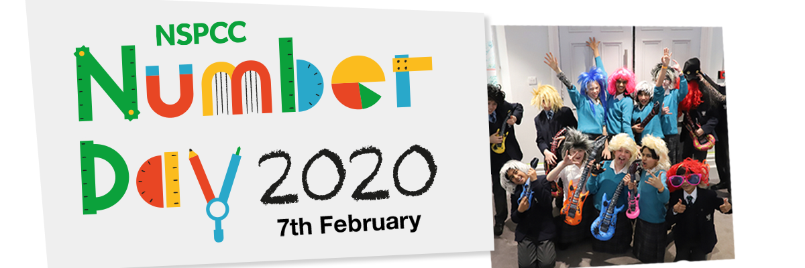

Dear parents and carers,
We are excited to announce that we will be taking part in NSPCC Number Day on Friday 7th February 2020, when the children will take part in fun maths activities throughout the day!
It’s a charitable event so we are fundraising by holding a Dress Like Your Avatar Day.
For a small donation to the NSPCC, children can dress up as a [Times Table Rock Star avatar] or [a robot from NumBots] for the day. << TEACHERS – AMEND AS APPROPRIATE
Making maths meaningful
To help raise money for the NSPCC, we are asking for a small donation (suggested £1.00) and we’d love everyone in the school to take part in this special event. We are looking forward to seeing all your amazing costumes. The children can be as exciting and inventive as they like.
All the money we donate to the NSPCC will help to fund their vital services such as Childline and the NSPCC Speak out Stay safe Programme, making an enormous difference to children today and to the lives of children tomorrow.
Please note that it’s entirely optional for your child to dress like an avatar and it’s optional for you to make a donation. Please speak to your child’s class teacher if you have any queries about Number Day.
Thank you for your support.
Best wishes,
<Name> <Your school details>

More information:
nspcc.org.uk/numberday | nspcc.org.uk/onlinesafety | ttrockstars.com | numbots.com

